PACE CURRICULUM
RESOURCE NAVIGATION GUIDE

Resources Developed for the PACE Pilot 2021-22 Cohort

TABLE OF CONTENTS
PACE PROGRAM BACKGROUND 3
PACE Pilot Structure 4
VAST Model 5
PACE CURRICULUM 6
Phase 1 Activities 6
Phase 1 Syllabus 7
RESOURCES FOR FACILITATORS 12
PACE Mindful Facilitation Guide 12
Vision Module Facilitator Resources 13
Assessment Module Facilitator Resources 13
Strategy Module Facilitator Resources 14
Timeline Module Facilitator Resources 14
RESOURCES FOR SELF-PACED LEARNING 15
Vision Module 15
Assessment Module 17
Strategy Module 19
Timeline Module 20

PACE PROGRAM BACKGROUND
The Partners Advancing Climate Equity (PACE) pilot program explored new models for investing in and building the capacity of frontline communities. PACE was funded by the California Strategic Growth Council (SGC) and collaboratively developed and implemented by a multi-disciplinary team. The PACE Team includes SGC, CivicWell (formerly Local Government Commission), Climate Resolve, Urban Permaculture Institute (UPI), People’s Climate Innovation Center (formerly Climate Innovation at Movement Strategy Center), and The Greenlining Institute.

In its pilot year, PACE brought together a cohort of 22 frontline community leaders from across California – collectively referred to as PACE Leaders – to learn together, tackle shared challenges, and build capacity for advancing climate equity objectives, both locally and throughout the state. The PACE Curriculum was designed to help PACE Leaders achieve the following core learning objectives and near-term intended outcomes.
LEARNING OBJECTIVE | NEAR-TERM INTENDED OUTCOMES FOR PARTICIPANTS
Leverage available resources to advance local climate resilience and social equity priorities | - Lay the groundwork to support successful grant applications  - Clearly articulate your community’s vision and priorities for equitable climate resilience  - Connect with peers and mentors from across California
Form and sustain cross-sector partnerships that enhance collective impact | - Map out local and regional opportunities for new partnerships  - Learn about effective methods for building consensus and achieving collective breakthroughs  - Lead trainings to build the capacity of your networks and local ecosystems
Create data-driven, community-led needs  assessments and action plans | - Use tools like Cal-Adapt, CalEnviroScreen, and Healthy Places Index to understand neighborhood-level data  - Learn how to analyze community assets, strengths, barriers, and needs to inform action  - Learn about case studies and models for addressing climate change and social equity issues
Navigate state funding programs, policies, and resources | - Understand State goals related to mitigating and adapting to climate change  - Become more well-versed in California Climate Investments and other State resources  - Establish contacts at key State agencies to support ongoing engagement

PACE Pilot Structure
The PACE pilot followed a fully virtual format, implemented through two 6-month phases. This structure enabled PACE Leaders to learn a common set of skills, tools, and frameworks with their peers while also receiving individualized assistance to address their specific needs and priorities. Phase 1 took place February through July 2021 and Phase 2, October 2021 through March 2022.

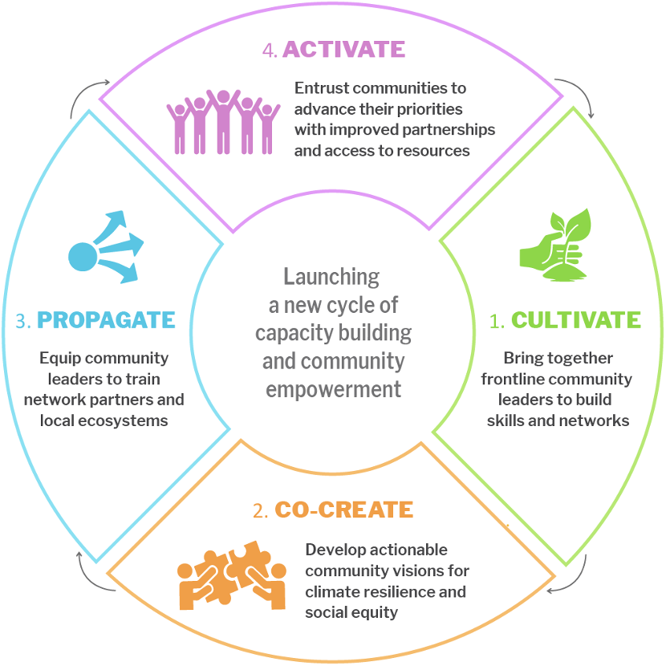
Phase 1 delivered the core PACE Curriculum
through a series of weekly cohort-based
and small group workshops and activities
for PACE Leaders to cultivate key
connections, skills, and field
knowledge and connections.
PACE Leaders also worked
to co-create their community’s
climate equity vision and
actionable community needs
assessments.

Phase 2 then provided tailored
technical assistance to help each
PACE Leader propagate new
learnings and skills to their
network partners, to set in motion
an ongoing cycle of capacity building.
Technical assistance also helped
PACE Leaders apply new learnings
to their work and activate new
partnerships, projects, and pathways for
bringing their community’s climate equity vision to life.

At its core, PACE aims to shift power to frontline communities to lead equitable, climate-resilient community solutions and shape State priorities and programs. The PACE Team envisioned a connected and mutually supportive network of emboldened community leaders with the capacity, partnerships, and drive to facilitate and catalyze local climate action. This vision is premised on a belief that collective liberation can be achieved by enabling communities to determine their own paths to climate resilience.

The PACE Curriculum was designed to work towards this ambitious vision, providing a variety of experiential learning activities and resources to support PACE Leaders, which have since been adapted to help other frontline community leaders build capacity.

VAST Model
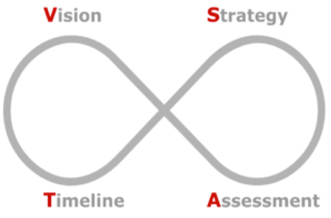
The Vision-Assessment-Strategy- Timeline (VAST) model, created by Urban Permaculture Institute (UPI), has been used to build community capacity and eco-literacy to address the challenges of adaptation and resilience planning, especially in communities that have experienced generations of marginalization and exclusion. The PACE Curriculum followed the VAST model, and the pilot’s overarching learning objectives and intended outcomes for participants were translated into the module-specific objectives.

Vision: Development of explicit, aligned, and collective goals.
- Increased understanding of the broader causes, impacts, and connections of climate change
- Ability to articulate the connections between climate change and equity
- Increased knowledge of community-driven planning and strategies to move towards community ownership
- Ability to demonstrate how community priorities align with or are impacted by climate change
- Ability to identify key factors contributing to effective partnerships

Assessment: An assessment of assets and existing conditions in a community as well as thorough understanding of the jurisdiction and motivations of stakeholders.
- Greater understanding of local ecosystems and partnership opportunities
- Increased knowledge of State climate policies
- Increased understanding of how to navigate existing climate tools
- Ability to utilize tools to extract neighborhood-level data
- Ability to identify community assets to inform actionable strategies

Strategy: A process to consider multi-benefit solutions that align visions, assets, issues, and opportunity.
- A more concrete understanding of solutions that can be applied to their community work
- Increased knowledge of state resources including funding, policies, and decision-making processes
- Increased understanding of the financial landscape supporting climate solutions

Timeline: A preliminary timeline for the implementation of the strategies organized by various characteristics, including time, resources, and responsible party.
- Increased understanding of grant writing process and best practices
- Increased understanding of co-developing grant applications with partners
- Ability to identify and clearly articulate community needs and priorities

PACE CURRICULUM

Phase 1 Activities
Phase 1 of the PACE program includes four main types of activities: Full Cohort Sessions, Learning Groups, Supplemental Sessions, and Independent activities often involving Community Needs Assessment development. Participation in Full Cohort Sessions and Learning Groups, as well as Community Needs Assessment development, were essential for completing the PACE Curriculum. PACE Leaders convened as a full cohort or in small groups on a weekly basis throughout the first 6-month phase, which helped to maintain momentum and deepen relationships.

Full Cohort Sessions
These two-hour, biweekly sessions gathered the full cohort for experiential learning. Sessions often involved presentations and interactive activities to deliver core PACE Curriculum topics.

Learning Groups
These one-hour, biweekly sessions gathered cohort members in smaller groups to dive deeper into Full Cohort Session topics, practice new skills, hold topic- or region-specific discussions, and build deeper peer relationships.

Independent Activities
Independent activities were assigned as “HomeFun” and primarily involved Community Needs Assessment development, as well as participation in evaluation activities and one-on-one progress check-in calls with PACE Team members.

Supplemental Sessions
Optional one-hour sessions were organized throughout Phase 1 to support deeper learning and elevate existing expertise within the cohort. Key types of sessions included:
- Supplemental trainings organized by the PACE Team based on PACE Leaders’ expressed interests, such as on climate planning and grant management.
- Peer exchanges organized by volunteer PACE Leaders to lead a presentation and facilitate discussions, such as on storytelling, advocacy, and youth leadership.
- Networking activities to build and strengthen relationships with local and regional partners, state agencies, and other key stakeholders.
- Office hours were also held by the PACE Team on a weekly basis (Tuesdays, 1-2pm and Thursdays, 2-3pm). Office hours are not reflected in the syllabus.

Phase 1 Syllabus
LAUNCH
Objectives: To weave connections between cohort peers and mentors.
Topics: Sankofa; PACE Program Overview; Networking
DATE | LAUNCH ACTIVITY
February 19, 2021 | Full Cohort Session #1  Sankofa, Group Agreements, and Program Overview
February 26, 2021 | Learning Groups #1  Web of Connections to reveal cohort connections
N/A | Independent  Build your own “PACE Camino,” individual roadmaps indicating supplemental activities (i.e., optional) of interest
With the sudden passing of PACE Leader Felicia “Fe Love” Lenee Williams, Full Cohort Session #2 and Learning Groups #2 were fully dedicated to honoring Fe Love’s passing.
VISION I
Objectives: To provide a high-level overview of systems through a climate equity lens, including the interdepencies of human, ecological, and built systems (local to regional to global); and to begin crafting community visions for climate equity.
Topics: Systems View on Planet and Equity; Community Systems Assessment; Making Equity Real
DATE | VISION I ACTIVITY
March 19, 2021 | Full Cohort Session #3  Systems, Making Equity Real, and Equity Gallery Walk
March 25, 2022 | Supplemental Activity  PACE Cohort Speed Networking
March 26, 2021 | Learning Groups #3  Operationalizing Equity and Facilitation Practice
April 1, 2022 | Supplemental Peer Exchange  The Art of Storytelling
N/A | Independent  CNA Development: Community Profile and Racial Equity Evaluation
VISION II
Objectives: To deepen understanding of the spectrum of community engagement to facilitate community participation in solutions development and decision-making; and to explore case studies for establishing lasting agreements between local government and community residents.
Topics: Community-Driven Climate Resilience Planning; Community Engagement; Partnerships
DATE | VISION II ACTIVITY
April 2, 2021 | Full Cohort Session #4  Spectrum of Community Engagement to Ownership
April 8, 2022 | Supplemental Activity  Spanish Terminology
April 9, 2021 | Learning Groups #4  Barriers to Partnerships and Relationship Mapping
April 15, 2022 | Supplemental Peer Exchange  Community Engagement Strategies
N/A | Independent  CNA Development: Relationship Mapping and Community Priorities

ASSESSMENT I
Objectives: To learn effective methods for building consensus and achieving collective breakthroughs; and to understand State goals related to mitigating and adapting to climate change.
Topics: Principles of Community; Group Governance
DATE | ASSESSMENT I ACTIVITY
April 16, 2021 | Full Cohort Session #5  Group Governance and Decision-making Models
April 22, 2022 | Supplemental Training  State Climate Policies
April 23, 2021 | Learning Groups #5  VAST Model and Case Studies
April 29, 2022 | Supplemental Peer Exchange  Youth Leadership Development, Engagement, and Organizing
N/A | Independent  CNA Development: Asset Mapping and Power Mapping
Between Assessment I and Assessment II, a 2-week break from Full Cohort Sessions and Learning Groups provided PACE Leaders with additional time to work on their CNAs.
ASSESSMENT II
Objectives: To use tools like Cal-Adapt, CalEnviroScreen, and Healthy Places Index to understand neighborhood-level data; and to learn how to analyze community assets and to inform planning.
Topics: Tool Demos; Data Equity; Asst Mapping; Climate Equity Analysis; Storytelling
DATE | ASSESSMENT II ACTIVITY
May 13, 2021 | Supplemental Peer Exchange  Advocacy & Coalition Building
May 14, 2021 | Full Cohort Session #6  Making Equity Real Applied and Live Tool Demonstrations
May 20, 2021 | Supplemental Training  Tool Demos Part 2
May 21, 2021 | Learning Groups #6  The Power of Collective Storytelling
N/A | Independent  CNA Development: Climate Equity Analysis

STRATEGY I
Objectives: To learn strategies and models for addressing climate change and social equity issues
Topics: Climate Equity Solutions; System Levers; Decolonizing Solutions; Solutions Stacking
DATE | STRATEGY I ACTIVITY
May 25, 2021 | Full Cohort Session #7  Climate, Equity, and Indigenous Practices and Solutions Stacking
May 27, 2021 | Supplemental Peer Exchange  Community-based COVID Responses
June 3, 2021 | Supplemental Training  Climate Planning 101
June 4, 2021 | Learning Groups #7  Cultural Organizing and Indigenous Frameworks
N/A | Independent  CNA Development: Solutions Menu
STRATEGY II
Objectives: To clearly articulate community visions and priorities for equitable climate resilience; and to prioritize strategies and solutions based on community priorities and opportunities.
Topics: Community Priorities; Strategy Prioritization
DATE | STRATEGY II ACTIVITY
June 10, 2021 | Supplemental Peer Exchange  Frontline Climate Solutions and Case Studies
June 11, 2021 | Full Cohort Session #8  Deep Dive into CNA Toolkit Components for Strategy and Timeline
June 18, 2021 | Learning Groups #8  Anchoring Solutions in Historical and Global Contexts
N/A | Independent  CNA Development: Solution Prioritization

TIMELINE I
Objectives: To become well-versed in California Climate Investments and other State resources, including how to access State grants; and to understand the range of mechanisms available to fund larger projects through braided financing.
Topics: State Climate Grant Programs; Climate Finance; Community Asset Building
DATE | TIMELINE I ACTIVITY
June 24, 2021 | Supplemental Training  State Grants Portal
June 25, 2021 | Full Cohort Session #9  Funding vs. Financing, Asset Building Case Studies, State Budget Process, and an Overview of California Climate Investments
July 2, 2021 | Learning Groups #9  Desirability/Feasibility/Viability Framework and Donut Economics
July 9, 2021 | Supplemental Peer Exchange  Grant Success Stories
N/A | Independent  CNA Development: Solution Game Plan

TIMELINE II
Objectives: To learn effective strategies for writing grants, both independently and in a collaborative setting; and to build capacity to financially resource community-owned strategies.
Topics: Effective Grant Writing; Grant Writing for Collaboratives, Participatory Budgeting
DATE | TIMELINE II ACTIVITY
July 9, 2021 | Full Cohort Session #10  Participatory Budgeting
July 15, 2021 | Supplemental Training  Effective Grant Writing & Management
July 16, 2021 | Learning Groups #10  Deep Dive into CNA Toolkit Components for Strategy and Timeline  and Preparation for State Resource Fair
July 22, 2021 | Supplemental Peer Exchange  Mindful Facilitation Practices
N/A | Independent  CNA Development: Solution Game Plan

REVISION & CELEBRATION
Objectives: To experience the iterative nature of VAST; and to celebrate the completion of Phase 1 with cohort peers.
Topics: Reflection and Revisioning; CNA Presentations
DATE | TIMELINE II ACTIVITY
July 23, 2021 | Full Cohort Session #11  Revisit initial visions from a new perspective, celebrate the hard work, mentally prepare for Phase II
July 30, 2021 | Supplemental Activity  State Resource Fair & Networking
N/A | Independent  CNA Development: All Components; One-on-one Progress Check-ins  (on CNA Development and to inform Phase 2 Structure)

RESOURCES FOR FACILITATORS
PACE aimed to utilize a train-the-facilitator model to support both cohort members and other frontline community leaders in launching an ongoing cycle of capacity building. Materials from the pilot’s first phase, in which the core PACE Curriculum was delivered, have been adapted to enable other organizers and community leaders to replicate the PACE pilot’s first phase (in its entirety or relevant activities).

Key PACE resources for facilitators include include the PACE Mindful Facilitation Guide and a set of VAST Module-based Facilitator Resources, which include modifiable template agendas and additional resources from Full Cohort Sessions and Learning Groups organized as part of PACE Phase 1. The creation of these resources were led by Urban Permaculture Insitute (UPI) in collaboration with the full PACE Team.

We also recommend reviewing the PACE Final Report to gain a deeper understanding of the PACE pilot’s vision, structure, and early outcomes and PACE Recommendations Report, which offers cohort-based capacity building best practices, recommendations for addressing structural challenges faced by frontline communities, and additional learnings based on the collective experiences of PACE Leaders and the PACE Team.

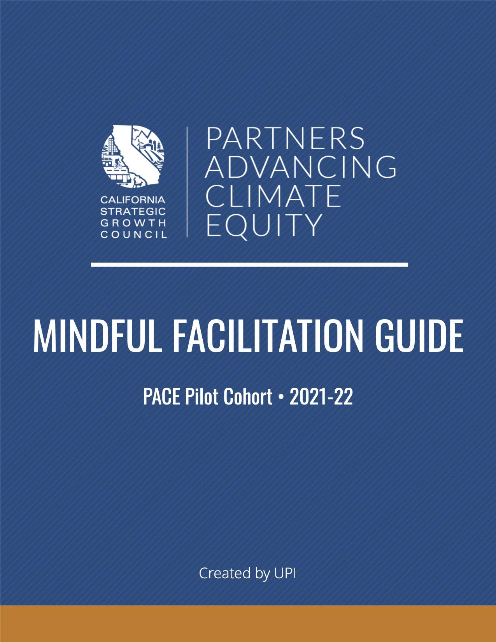
PACE Mindful Facilitation Guide
The PACE Mindful Facilitation Guide incudes key principles and frameworks for group facilitation, examples of interactive activities and icebreakers, and a set of group management strategies.

This resource is intended to support community leaders managing group dynamics, organizing cohort-based experiences, and facilitating collective impact efforts.

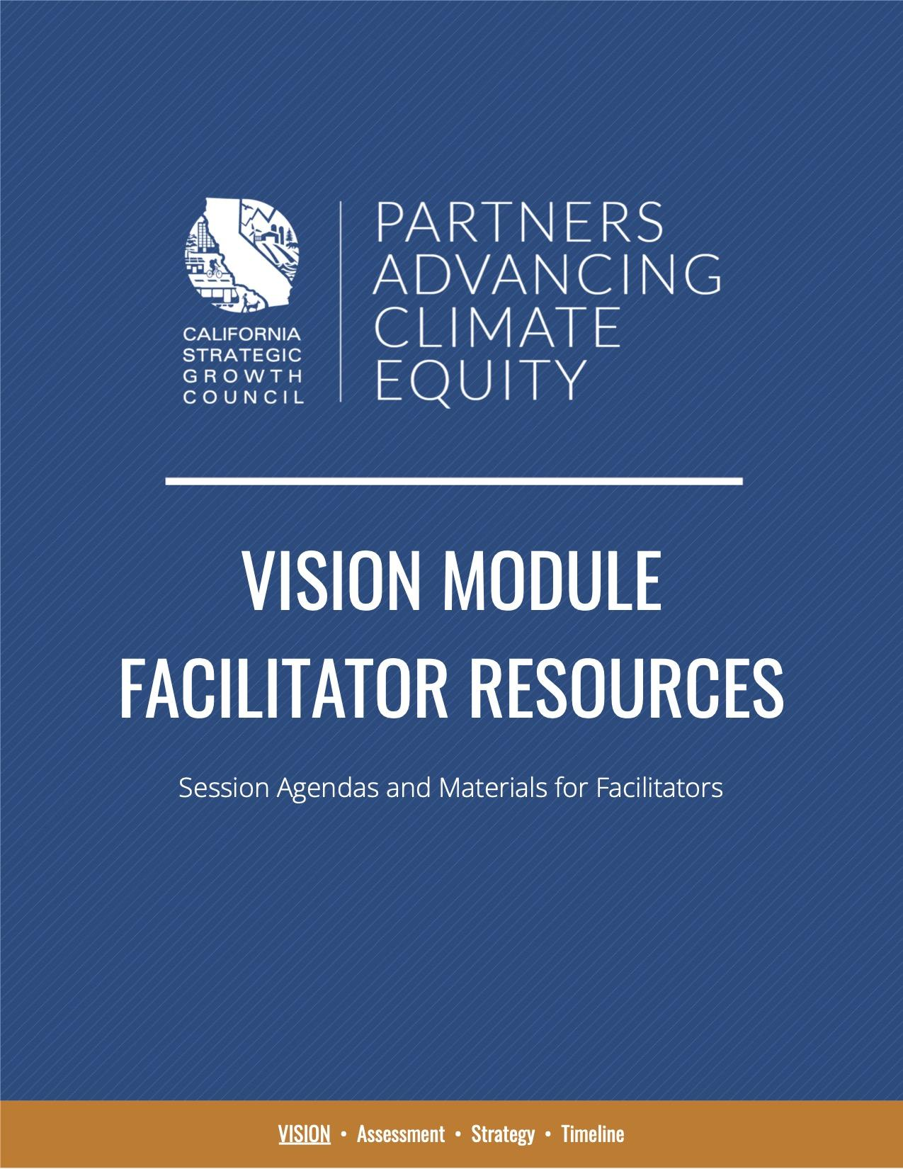
Vision Module Facilitator Resources
The goal of the Vision Module is to develop explicit, aligned, and collective community objectives that tap into cultural identity and values while trust-building and fostering meaningful relationships.

Vision Module Facilitator Resources includes a set of adapted facilitator agendas for Full Cohort Sessions and Learning Groups organized as part of the pilot’s Launch and Vision Module for others to modify and utilize.

It also includes additional templates and samples including Templates Slides, PACE Group Agreements, Jamboard Templates for Launch Sessions and Vision Module Sessions, worksheets for Equity Practices and Barriers to Effective Partnerships, and more.

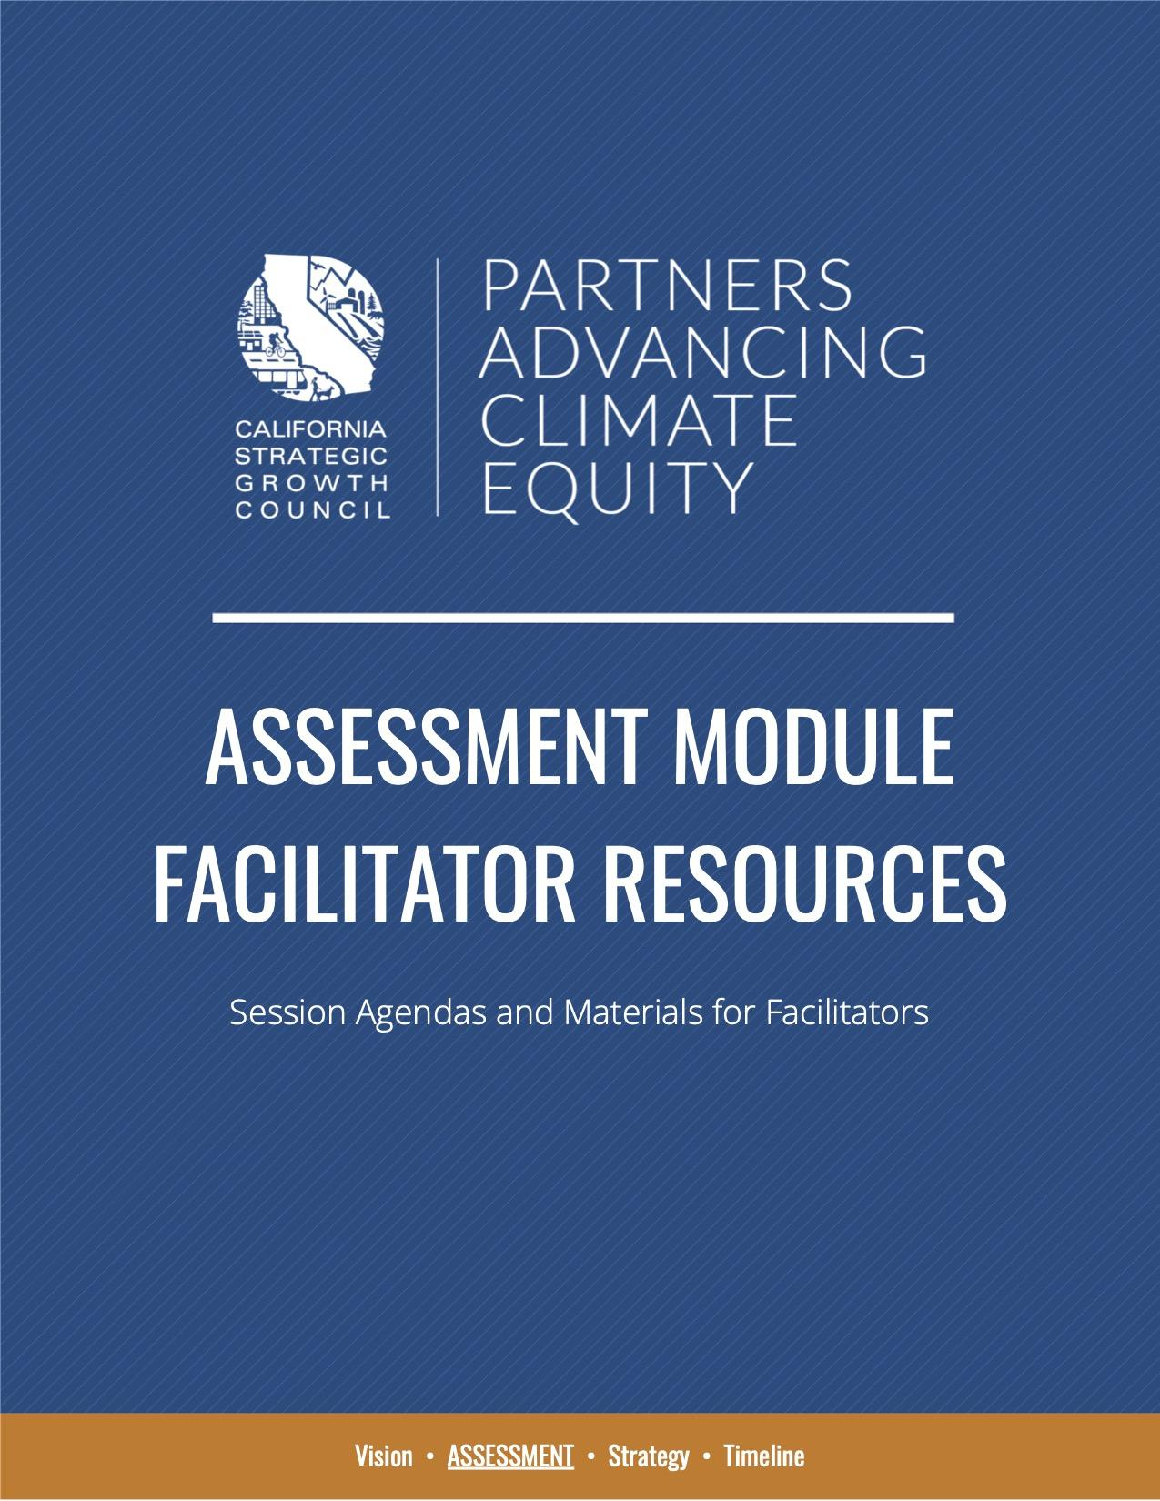
Assessment Module Facilitator Resources
The goal of the Assessment Module is to deepen the understanding of community needs by gathering an inventory of existing conditions through the mapping of present-day political, cultural, and physical assets and challenges.

Assessment Module Facilitator Resources includes a set of adapted facilitator agendas for Full Cohort Sessions and Learning Groups organized as part of the pilot’s Assessment Module for others to modify and utilize.

It also includes additional templates and samples including Templates Slides.

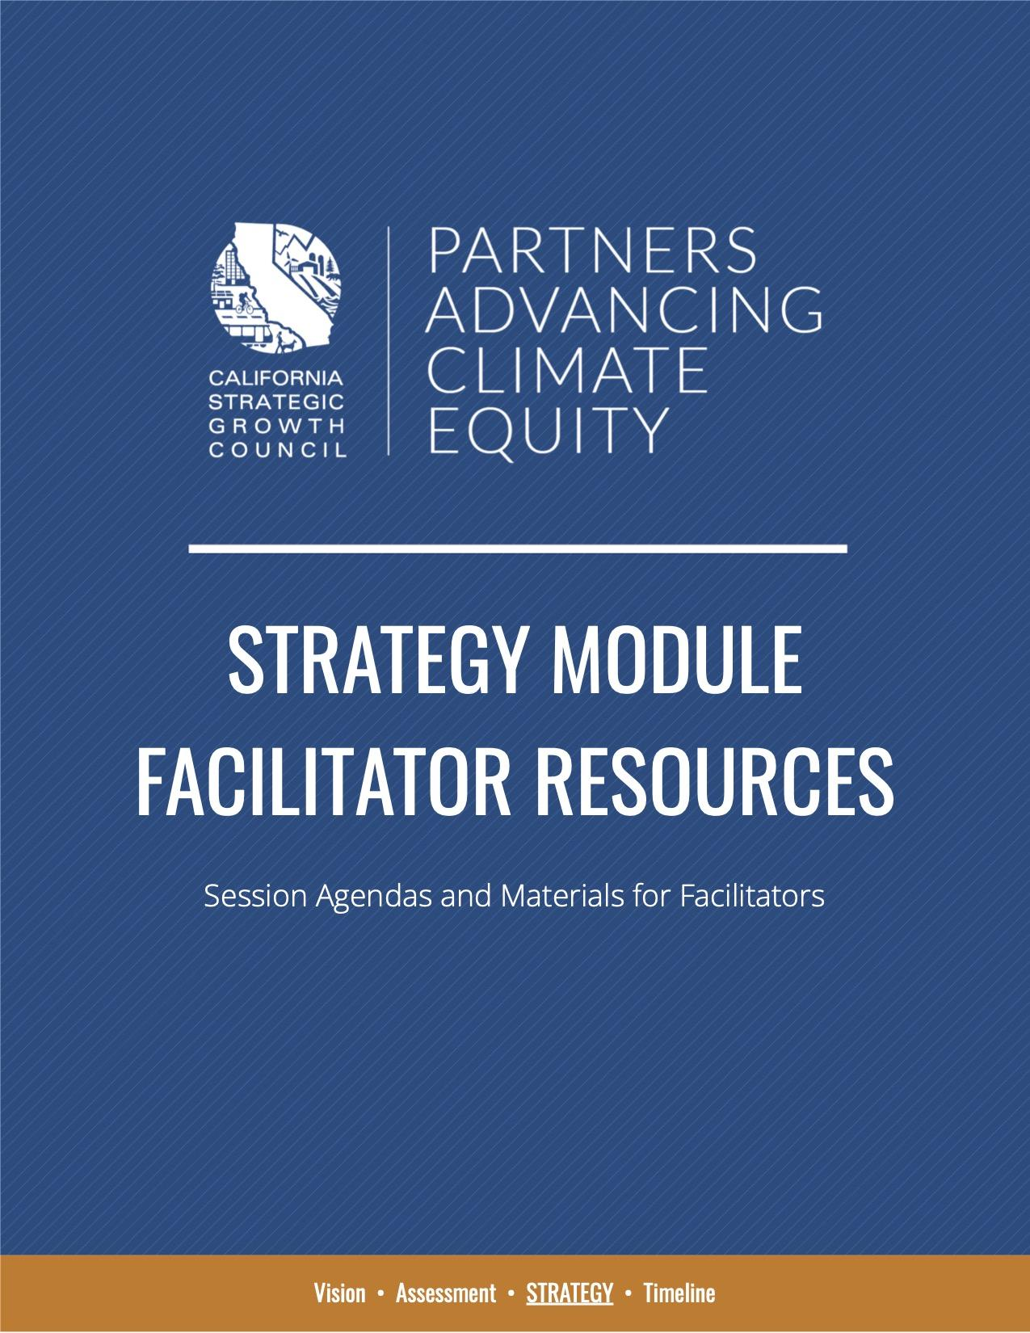
Strategy Module Facilitator Resources
The goal of the Strategy Module is to consider multi-benefit solutions that align visions, assets, issues, and opportunity, and to develop a menu of prioritized solutions tailored to community needs and priorities for climate equity.

Strategy Module Facilitator Resources includes a set of adapted facilitator agendas for Full Cohort Sessions and Learning Groups organized as part of the pilot’s Strategy Module for others to modify and utilize.

It also includes additional templates and samples including Templates Slides, Jamboard Templates for Strategy I Sessions and Strategy II Sessions.

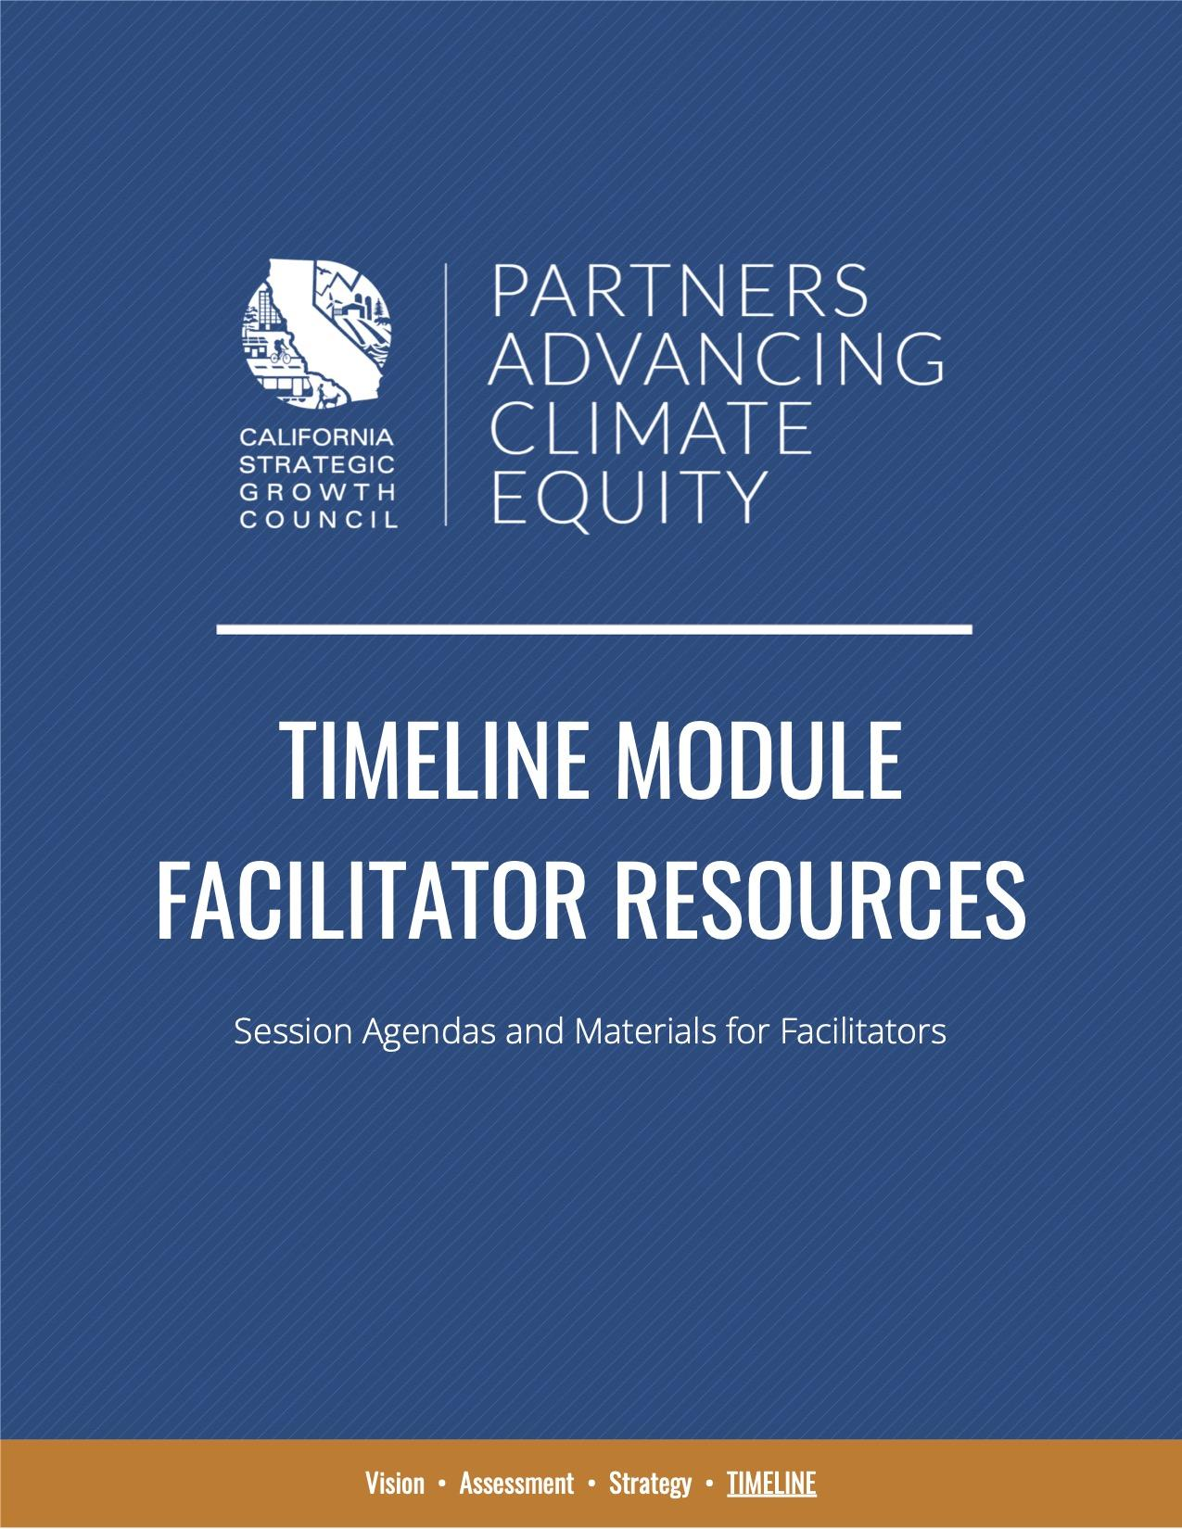
Timeline Module Facilitator Resources
The goal of the Timeline Module is to organize previously developed strategies to identify those that create the greatest impact yet require the least amount of change and then develop a plan for the implementation of these strategies. Topics covered in the curriculum include California Climate Finance, Code Switching, and Effective Grant Writing.

Timeline Module Facilitator Resources includes a set of adapted facilitator agendas for Full Cohort Sessions and Learning Groups organized as part of the pilot’s Timeline Module for others to modify and utilize.

It also includes additional templates and samples including Template Slides and Case Studies of Asset Building.

RESOURCES FOR SELF-PACED LEARNING
In addition to supporting facilitators, the PACE Curriculum was also designed to support self-paced learning for frontline community leaders, organizers, and advocates to build their own capacity to advance community-driven climate equity solutions.
Key PACE resources for self-paced learning include the Community Needs Assessment Toolkit, Presentations and Recordings from Cohort Sessions, and Compilations of Resources by Topic, which are organized by VAST module below.

Vision Module
# | STEP | RESOURCE | GUIDANCE
1 | Familiarize yourself with the PACE Community Needs Assessment (CNA) development process. | CNA Toolkit  Introduction &  CNA Toolkit Outline | The development of a CNA is an essential aspect of the PACE Curriculum as a core avenue for building capacity through experiential learning.
2 | Start your CNA by identifying your community. | CNA Toolkit  Community Profile: Step 1.1 | To build results-oriented capacity, identify the community you want to focus your efforts in and with to address community needs and climate equity priorities.
3 | Build your understanding of storytelling practices and resources. | The Art of Storytelling  PACE Peer Exchange Resources | This step is in preparation for Step #4.
4 | Continue developing your CNA by crafting your community’s story. | CNA Toolkit  Community Profile: Step 1.2 | This is a great opportunity to deepen your engagement with community members and hear their stories.
5 | Continue developing your CNA by identifying your community’s attributes. | CNA Toolkit  Community Profile: Step 1.3 | Gathering community data after you reflect on your community’s shared experiences and conditions can offer a new lens to data collection. Are there any uncommon data points to collect?
6 | Watch the Making Equity Real presentation recording. | Vision Sessions Recording  Time: 0:06 - 20:33 | Begin to build your understanding of racial equity. Additional resources include The Greenlining Institute’s Making Equity Real Guidebook and Racial Equity Toolkit.
7 | Continue developing your CNA by evaluating your community’s racial equity issues. | CNA Toolkit  Racial Equity Evaluation: Step 2.1 | This CNA step also involves identifying how racial equity issues could be worsened by climate change. Regional reports from California’s Fourth Assessment can be helpful resources.
8 | Continue developing your CNA by evaluating how equity is embedded in your organization. | CNA Toolkit  Racial Equity Evaluation: Step 2.2 | Embedding equity in the core purpose and operations of your organization is a critical early step towards advancing racial/social equity in your community.
9 | Continue developing your CNA by identifying and assessing existing collaborators and allies. | CNA Toolkit  Relationship Mapping: Step 3.1 | Addressing systemic issues requires a coalition of diverse partners working towards a shared goal. This steps starts the relationship mapping process by focusing first on existing connections.
10 | Continue developing your CNA by evaluating gaps and identifying new potential partnerships. | CNA Toolkit  Relationship Mapping: Step 3.2 | As community needs evolve and climate disruptions present new challenges, new partnerships can help to overcome these challenges and advance more holistic, multi-benefit solutions.
11 | Continue developing your CNA by identifying strategies to address barriers to successful partnerships. | CNA Toolkit  Relationship Mapping: Step 3.3 | This step focuses on equipping you with a set of strategies to overcome common barriers to successful partnerships to support your ongoing efforts to build, sustain, and expand partnerships.
12 | Watch the Spectrum of Community Engagement to Ownership presentation recording. | Vision Sessions Recording  Time: 20:34 - 44:24 | Further your understanding by reviewing The Spectrum of Community Engagement to Ownership.
13 | Continue developing your CNA by compiling existing community input. | CNA Toolkit  Community Priorities: Step 4.1 | By first reflecting on community input already gathered, you can establish a baseline understanding to then determine gaps and shared priorities to further explore with your community.
14 | Continue developing your CNA by drafting your community’s vision for social equity and climate resilience. | CNA Toolkit  Community Priorities: Step 4.2 | This guide from Movement Strategy Center on The Practices of Transformative Movements demonstrates the importance of  visioning to lead meaningful movements.
15 | Build your understanding of inclusive community engagement strategies. | Community Engagement  PACE Peer Exchange Resources | Community engagement is an ever-evolving practice. Look for additional case studies for inspiration and replicable models to support your efforts.
16 | Consider how you can adapt community engagement approaches in light of the ongoing pandemic. | COVID Responses  PACE Peer Exchange Resources | This presentation recording from the Peer Exchange highlights how Pacoima Beautiful has been engaging and supporting community members throughout the pandemic.
17 | Consider how you can foster and facilitate youth engagement. | Youth Engagement  PACE Peer Exchange Resources | This presentation recording from the Peer Exchange highlights several case studies demonstrating the power of youth and strategies for effective youth engagement in community efforts.
18 | Continue developing your CNA by assessing your organization’s community engagement approach. | CNA Toolkit  Community Priorities: Step 4.3 | This CNA step involves high-level planning for your next community engagement activity. Draw from your experiences and new learnings from your PACE learning process to identify early planning steps.

Assessment Module
# | STEP | RESOURCE | GUIDANCE
1 | Watch the Decision Making & Consensus Protocols presentation recording. | Assessment Sessions Recording  Time: 0:04 - 22:25 | Here are the decision making protocols established by the PACE Team, which guided the collaborative decisions we made throughout the program.
2 | Continue developing your CNA by identifying existing community assets. | CNA Toolkit  Asset Mapping: Step 5.1 | Leverage learnings from community engagement, partnership development, and group governance to engage others in the asset mapping process.
3 | Continue developing your CNA by mapping your community’s assets. | CNA Toolkit  Asset Mapping: Step 5.2 | Consider exploring partnerships with an academic or research institution to support mapping efforts.
4 | Watch the Principles of Permaculture presentation recording. | Assessment Sessions Recording  Time: 22:26 - 38:37 | Consider deepening your understanding of permaculture principles by taking a course, such as ones offered by the Urban Permaculture Insititute.
5 | Continue developing your CNA by assessing opportunities to lift up community assets and address any gaps. | CNA Toolkit  Asset Mapping: Step 5.3 | Consider how the principles of permaculture can inform ways in which community assets can be enhanced.
6 | Watch the Data & Tools presentation recording. | Assessment Sessions Recording  Time: 38:37 - 1:10:25 | This presentation provides demos for Cal-Adapt, Healthy Places Index, and CalEnviroScreen.
7 | Explore additional tools that can support data collection efforts and the climate equity analysis as part of your CNA. | Climate Tools & State Adaptation Resources  PACE Supplemental Training Resources | This presentation recording from the PACE Supplemental Training features the adaptation planning process,  the State’s Adaptation Clearinghouse and RAP-Map, and more.
8 | Continue developing your CNA by assessing your community’s exposure to climate change impacts. | CNA Toolkit  Climate Equity Analysis: Step 6.1 | The priority climate impacts you identify as part of this CNA step will set the stage for future CNA development.
9 | Continue developing your CNA by assessing your community’s adaptive capacity. | CNA Toolkit  Climate Equity Analysis: Step 6.2 | This is a great opportunity to begin connecting the dots between community priorities, asset mapping, and priority climate impacts.
10 | Continue developing your CNA by evaluating how existing inequities will be exacerbated by climate impacts and pollution. | CNA Toolkit  Climate Equity Analysis: Step 6.3 | Use the tools you learned about in previous steps to collect climate data for your community. As with all other CNA sections, the data you collect here can serve as a quick reference for future grant applications.
11 | Build your understanding of key State climate policies and processes. | State Climate Policies  PACE Supplemental Training Resources | This presentation recording from the PACE Supplemental Training covered covered the cap-and-trade system, State adaptation planning resources, and regional planning processes.
12 | Learn about key local planning processes and opportunities to integrate equity into long-range plans. | Climate Planning 101  PACE Supplemental Training Resources | This presentation recording from the PACE Supplemental Training includes information on the enforcement of planning regulations, the development and implementation of General Plans, the incorporation of SB-1000 objectives into climate planning, and more.
13 | Continue developing your CNA by identifying key institutions making decisions that affect your community. | CNA Toolkit  Power Mapping: Step 7.1 | Consider the institutions most relevant to your work and decision-makers to build relationships with to advance your community’s priorities.
14 | Continue developing your CNA by identifying opportunities to influence decision-making. | CNA Toolkit  Power Mapping: Step 7.2 | Consider reaching out to your partners and agency contacts to identify planning and policymaking processes that you can influence before researching online.
15 | Continue developing your CNA by creating a power map of decision-makers and influencers. | CNA Toolkit  Power Mapping: Step 7.3 | We recommend revisiting your power map from time to time. As new elected officials and staff come on board, your relationship with the agency could change (for the better or worse).
16 | Explore opportunities to build coalitions for collective advocacy. | Advocacy & Coalition Building  PACE Peer Exchange Resources | Creating an enabling policy environment for community-led solutions can help to catalyze, support, and sustain community efforts over time.

Strategy Module
# | STEP | RESOURCE | GUIDANCE
1 | Watch the System Levers and Respective Solutions presentation recording. | Strategy Sessions Recording  Time: 0:06 - 16:07 | This presentation introduces key frameworks to support you in identifying transformational solutions.
2 | Continue developing your CNA by identifying focus areas for solutions. | CNA Toolkit  Solutions Menu: Step 8.1 | Draw from prior CNA sections to inform this step, particularly 4.2, 5.1, and 6.1.
3 | Continue developing your CNA by compiling existing projects, programs, and initiatives and identify other potential solutions. | CNA Toolkit  Solutions Menu: Step 8.2 | Starting with a list of existing projects and initiatives can help to avoid unnecessary duplication or replication while providing greater insights into key gaps to address.
4 | Watch the Solution Game Plan and Types of Power presentation recording. | Strategy Sessions Recording  Time: 16:08 - 29:35 | This presentation focuses on how to go from an idea to an implementable solution, as well as ways to ensure equitable power structures.
5 | Continue developing your CNA by identifying your priority solution. | CNA Toolkit  Solution Prioritization:  Step 9.1 | The CNA process encourages users to select one priority solution as additional strategies will be stacked later on to create a multi-benefit solution.
6 | Continue developing your CNA by assessing opportunities and potential pitfalls for implementation. | CNA Toolkit  Solution Prioritization:  Step 9.2 | Analyzing the opportunities available to support your solution, such as grant programs, can provide clearer pathways towards implementation.

Timeline Module
# | STEP | RESOURCE | GUIDANCE
1 | Watch the California Climate Finance presentation recording. | Timeline Sessions Recording  Time: 0:05 - 52:13 | This presentation provides an overview of funding vs. financing, integrated financing solutions, the State budget process, and California Climate Investment programs.
2 | Watch the State Climate Grants Portal presentation recording. | State Climate Grants Portal  PACE Supplemental Training Recording | This presentation provides a demo of the California Grants Portal to help users navigate the tool to find relevant grant opportunities.
3 | Watch the Grant Success Stories presentation recording for inspiration and ideas to support your efforts. | Grant Success Stories  PACE Peer Exchange Recording | You can see additional resources shared during this PACE Peer Exchange here.
4 | Watch the COVID Responses presentation recording. | COVID Responses  PACE Peer Exchange Recording | We recommend this step for those looking to provide COVID-related support for communities. Additional resources shared during this PACE Peer Exchange are available here.
5 | Continue developing your CNA by refining your priority solution to consider multiple benefits. | CNA Toolkit  Solution Game Plan:  Step 10.1 | Try to strike an appropriate balance between creating multi-benefit solutions while staying focused on your priority.
6 | Continue developing your CNA by creating your ask for engaging partners and decision-makers. | CNA Toolkit  Solution Game Plan:  Step 10.2 | Transformational solutions that address deeply entrenched equity issues and catastrophic climate impacts require partnerships. This CNA step aims to help you think through how you intend to engage partners and for what purposes.
7 | Watch the Participatory Budgeting presentation recording. | Timeline Sessions Recording  Time: 52:14 - 1:34:54 | If this topic is of interest, we recommend exploring resources from the Participatory Budgeting Project.
8 | Continue developing your CNA by defining key milestones and develop a high-level work plan. | CNA Toolkit  Solution Game Plan:  Step 10.3 | This CNA step is focused on identifying early actions to move your solution forward. This section could also be adapted to instead create a high-level work plan to inform a grant application
9 | Watch the Effective Grant Writing and Management presentation recording. | Effective Grant Writing and Management  PACE Supplemental Training Recording | A set of templates were shared as part of this PACE Supplemental Training that we encourage you to explore and utilize if helpful. These templates are intended to determine if a funding opportunity should be pursued and to support collaborative grant writing processes.
10 | Learn about strategies to support racial healing, self-care, and community building through the cultivation of joy. | Frontline Climate Solutions  PACE Peer Exchange Resources | Climate equity work can be challenging, exhausting, and even painful. But this critical work can also be rewarding, re-energizing, and a source of joy. This PACE Peer Exchange focused on resources to support and sustain organizers leading power-building efforts.

